HCI Project 3

By Brian Nguyen, Woo-Jae Lee, and Cody Fulford

University of Calgary

CPSC 481 - HCI

# Affinity Diagram

To develop our affinity diagram, we first each drew some sketches for the user interface. We did these drawings individually so that we could bring the ideas together at the end and compare the ideas from different perspectives. Next we discussed the strengths and weaknesses of our sketches by going through them one by one. We took turns speaking about our sketches while the other group members took notes about the strengths and weaknesses of their idea. After that each group member had a list of important design concepts from the sketches. After enumerating these design concepts, we spread them across a table and grouped them up into separate categories. Initially we had eight different categories for our design concepts:

* Important application design concepts (usability, modularity)
* Skill hill information
* Ratings
* Ski hill services
* Restaurants
* Transportation
* Emergency Services
* Multiple languages support

Finally, we reduced and combined these categories into four categories:

* Skill hill information
* Services that the resort offers
* Application design (usability, modularity, ease of use)
* Transportation (location of resort, restaurants)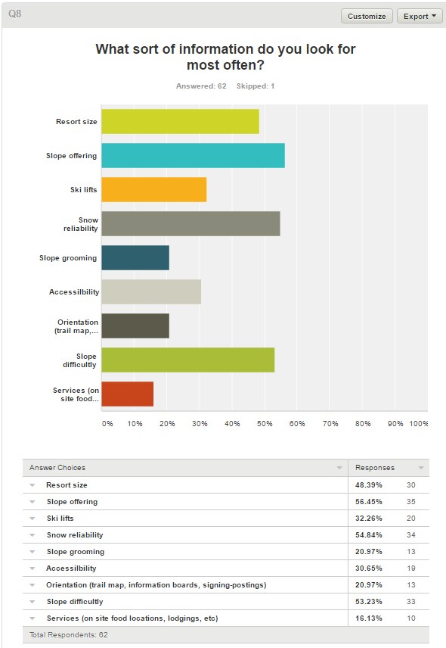

Per our survey results, we identified the major features that our stakeholders want to know about a resort. Our primary stakeholders are the people who are visiting the ski resorts for their leisure. Upon reflection of our sketches, we also produced similar results related to our survey. Weather, location, ski hill availability, and price were the major features that our application must have. These features are under the ski hill information category.

We also recognized that if our users are on the go on the skill hill, then they would be wearing gloves. An ideal app for our users would include buttons that are large enough so that they would be able press the buttons that they want. We also thought that a minimalistic design is ideal, perhaps a main menu that includes only the essential things. These concepts were included under the application design category.

We noticed that we had several concepts related to transportation. In P1, we determined that stakeholders such as travel agents would want to track several hundred resorts at the same time and make informed decisions for their clients. They would require transportation information as well as users who are skiing for just their leisure. We grouped together the following ideas under this category: resort location, restaurant location, distance, and map of resort. All of these concepts are related to the problem where given point A, how do I arrive at point B.

Finally, the last category is the services that a resort can offer. This category is related to the group of stakeholders comprised of resort owners and resort workers. Resort owners would want to showcase the accommodations that they can offer as well as emergency services and contact information. Potential resort workers would be interested in the contact information of say a restaurant so they could apply. Current resort workers such as ski patrols would use an overview map to get to somewhere if they did not have a map on hand. Coincidentally, some of the ideas that we came up with were emergency services, lost and found information, rental and restaurants information which all fall under this category and relate to these group of stakeholders.

# Polished Versions

We have chosen these three designs as the most promising for satisfying our customer’s needs. The main need for our users is ease of use. This is because our users will often be in a hurry to find the information that they need, or on a ski hill where they will be, for all intents, disabled. While our customers will not actually be disabled, it is important to think of them as such because of the gloves that many skiers wear. These gloves greatly increase the size of their fingers and reduce the responsiveness of the touchscreen. Even the gloves that are specially designed to work with touchscreens increases the size of the finger. Should the customers gloves not work with the touchscreen, it is possible that they will remove the gloves to use the application. This means that the users hags will most likely be cold and shaking. These limitations that the customer will probably have sound very like what we would have to design for older people. We can also assume that the customers will be using the application with both hands since they will be standing over the snow. We assume that the customer will hold the phone with one hand and use it with the other. If the customer leaves their glove on the hand that is holding the phone, the extra bulk of their gloves will cover some portions of the screen. The area that the gloves can cover will mostly be the middle of the vertical portion of the screen, extending towards the middle of the screen. These problems have pushed us towards design concepts that emphasize speed and ease of use. All our designs use large buttons to allow people with large finders and shaky hands to easily navigate our application.

The first sketch that you can see shows how we can arrange the screen showing information about a specific ski resort in a design that accommodates both speed and ease of use for those who are wearing gloves. It accomplishes this by having large buttons that extend into the middle of the window, this allows the customer to press the buttons even while their hands are shaking or they are wearing large gloves. The other aspect that this design exemplifies is speed. If the customer is not using our application, they are not currently skiing. Since the customer is wanting to ski more than use our application, having the information for a specific ski hill be hidden behind several menus would drive customers away as threw would get frustrated with our application. What we have designed to accommodate this need is that we have placed all the information that our studies in project 1 identified as most important directly on the front page of the individual ski resort page. This means that the current weather conditions, number of open lifts, and hill rating are displayed the moment that the user opens the specific ski resorts web page. This design worked to combine both concepts of ease of use and information display.

Thee second design that we decided was most promising focuses on the design aspect of large buttons. As you can see from the sketch, the buttons that we would be using are so large it only takes a few of them to fill a screen. While this design for the hotels does not have nearly as much information concentration as the first design concept, it can be used in a slower more deliberate way. What we mean by this is that the user will be less likely to make mistakes when the buttons are as large as they are at the expense of the customer being required to tap more buttons to get to some less critical information. What this design also allows though is more high level information such as photos, or distance to a hotel. This sort of information stands out since there is less information concentration and allows the client to quickly sift through potential options. Since there is less information to sort through, it is possible that this will increase the speed that the customer can use the application.

The third sketch that we have decided has high potential supports our design concepts of low clutter and high speed of information. Since there are so few buttons on the screen, it allows the user to focus on the information on the screen while removing the possibility of a mistake. Having most the information on the screen all at one time allows a user to quickly read through it and absorb the information without needing to scroll which can lead to mistakes.

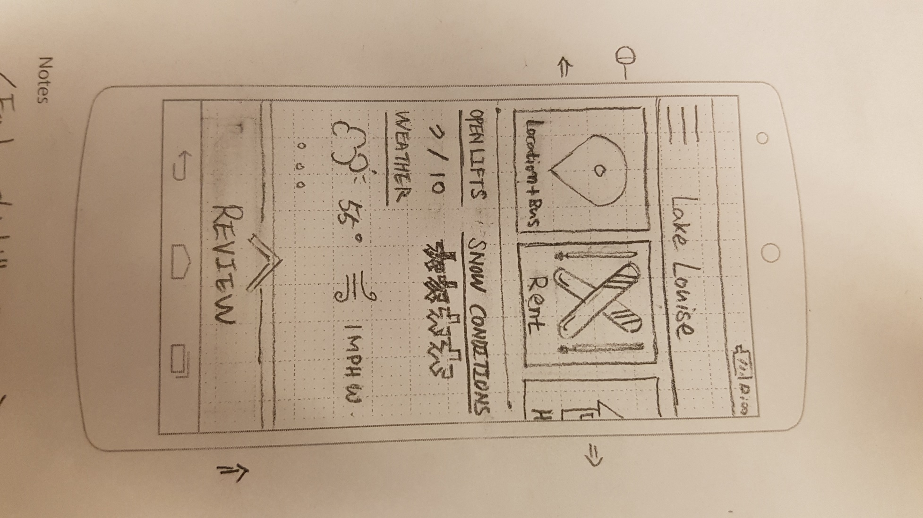

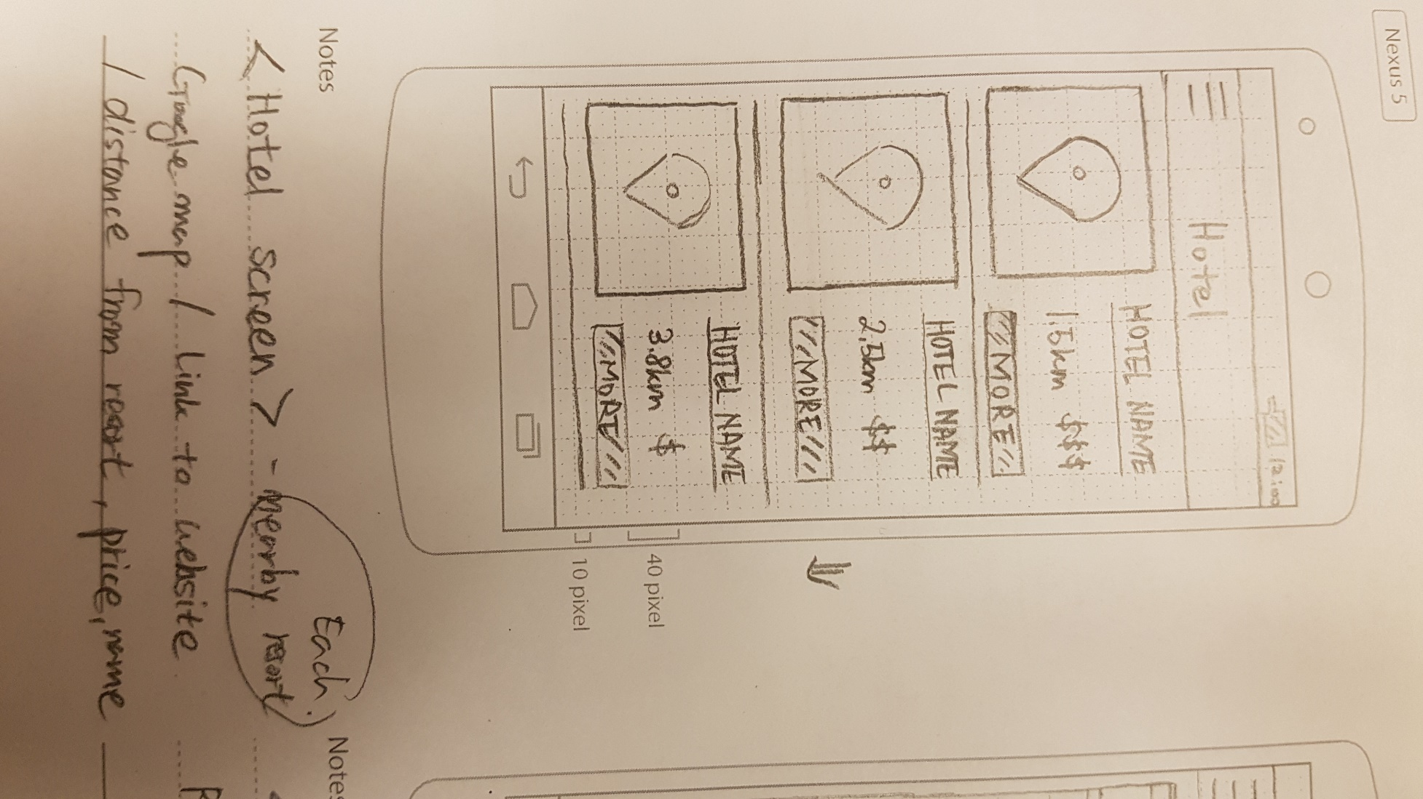

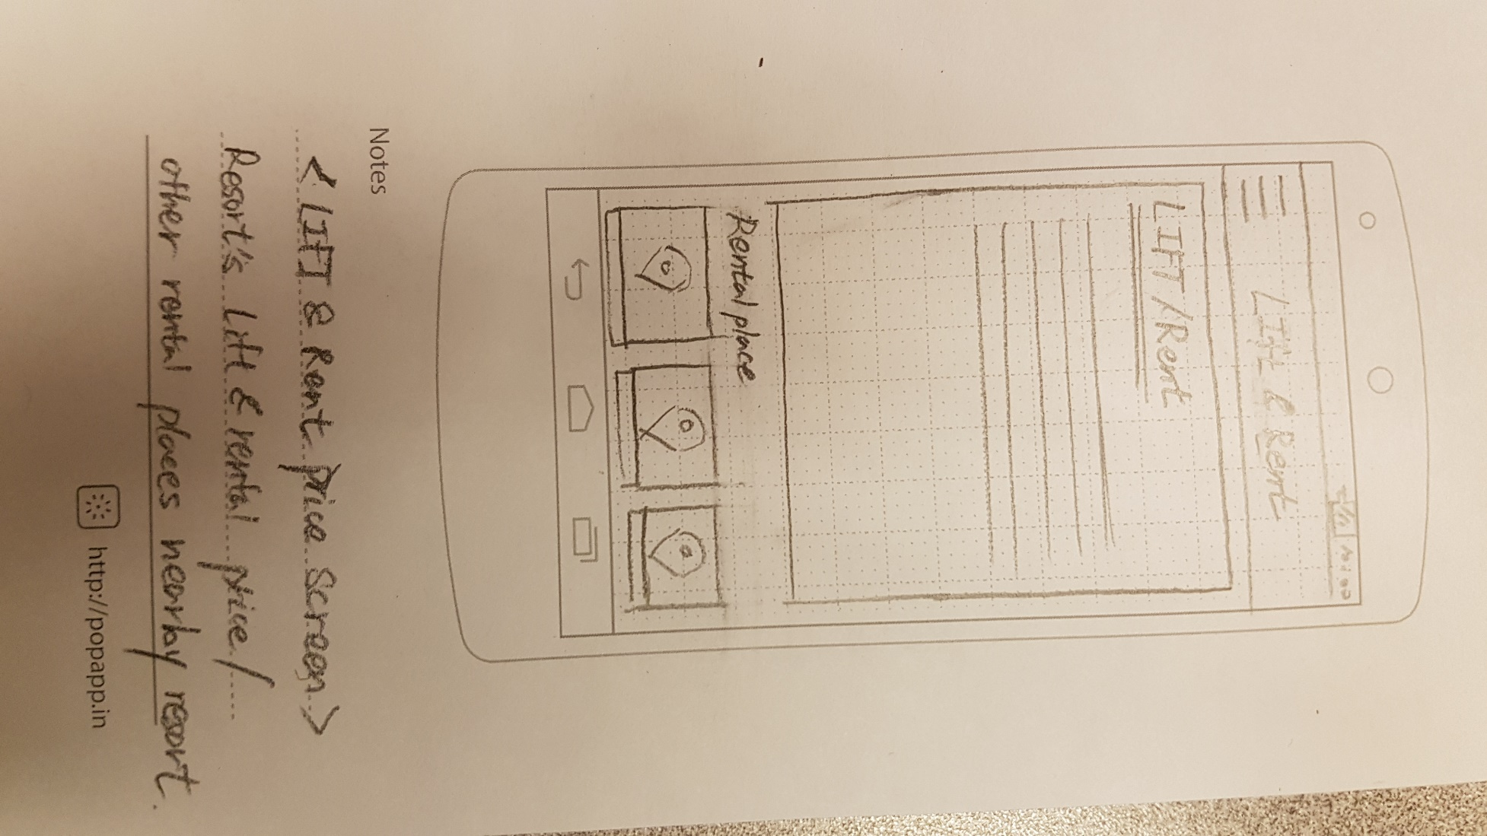

Tom is a foreigner an expert at skiing and he wants to go to ski at this weekend. He wants to see information about ski hills in Alberta, so downloaded our app and started.

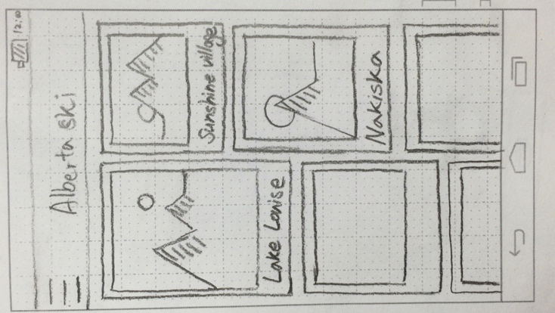

He looks the main screen which lists ski hills in Alberta with pictures. He taps the Lake Louise button.

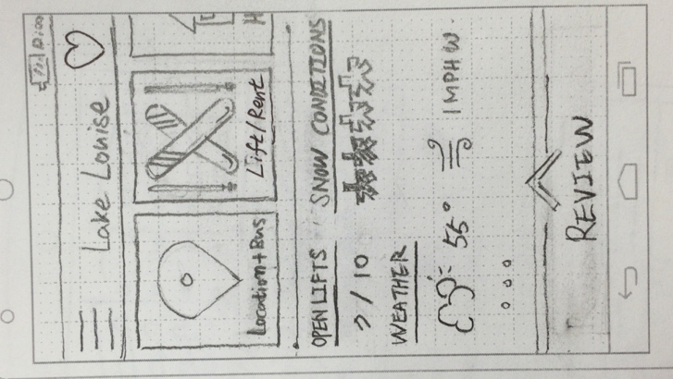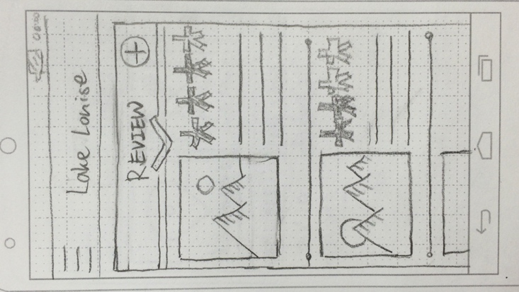

After he got in, he looks at information whether it is open or not, snow conditions, specific weather info. He swipes up the ‘Review’ at the bottom of screen to see the reviews

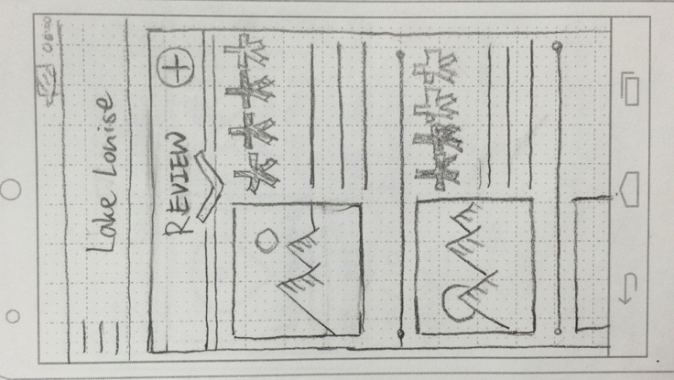



 He taps the one of the picture to see bigger image. After seeing overall information he thinks Lake Louise is quite good to ski and he decide to see more in detail

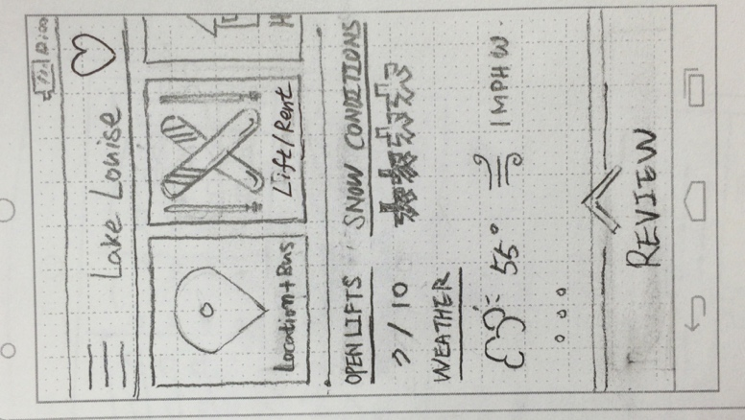

He swipes the button lists (Location & Bus, Lift & Rent, Hotel, Resort overview) and taps the Hotel button because he is going to sleep there one night.

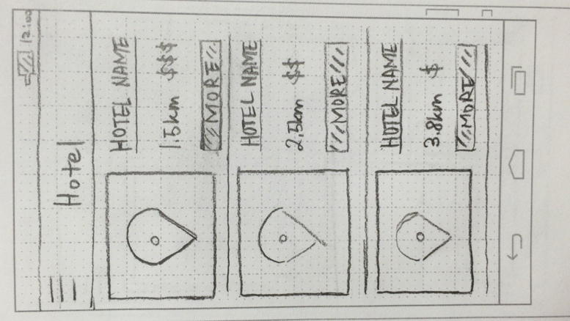

The list of hotels with small map comes up which is ordered by distance from ski hill. He taps the ‘more’ button in the top of list.

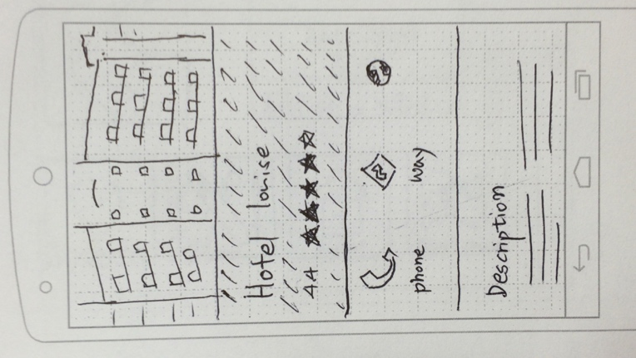

The app converts to browser app which shows the hotels website. After deciding which hotel he will reserve, he taps back to Lake Louise screen.

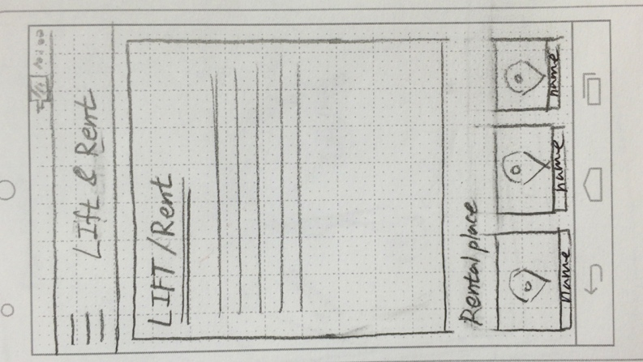

He taps the Lift & Rent button to see the price of rental fee and lift. He thinks the gear rental price of ski resort is quite expensive, so he decided to rent at the other rental place near ski hill.

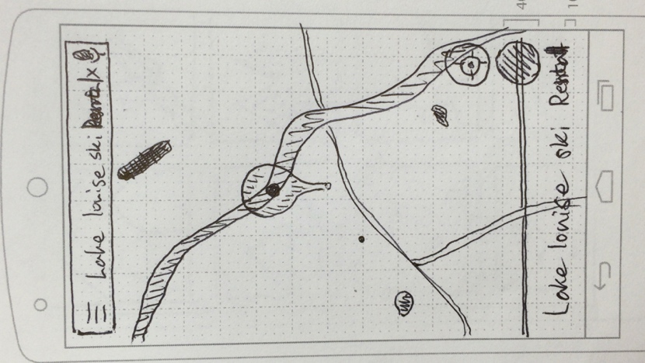

He taps one of the rental places at the bottom of screen. App converts to google map which shows the location of the rental place.

`

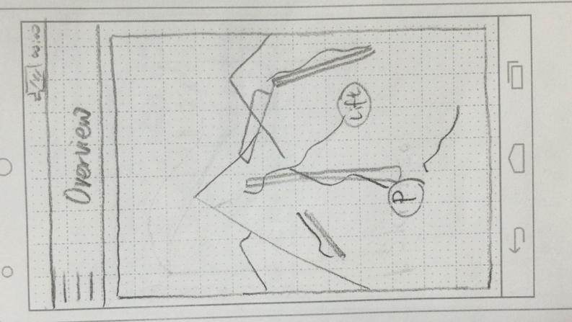

Now he is curious about overview of the ski resort so he taps the Resort overview button. Screen shows him the whole overview map of the ski hill. He pinches to zoom in and out to see in detail.

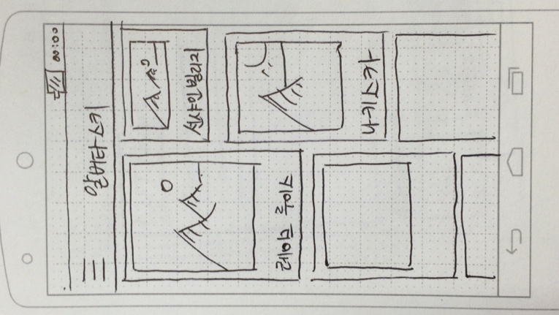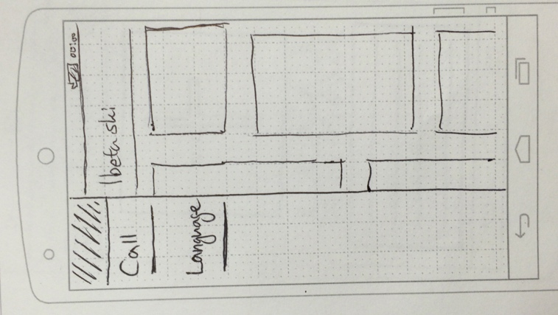

He has a friend from South Korea, so he taps the button language button to change the language to show the app to his friend readable.

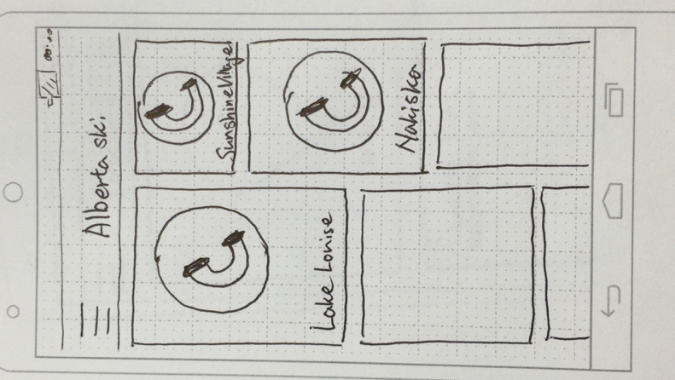

Now he is in the Lake Louise ski hill, he stumbled over and he got hurt. He taps hamburger button at the left-top of screen and taps the call. The all list of ski hills in main screen changes to calling button, and he tap the button of Lake Louise. Snow patrol came and he is safe now.

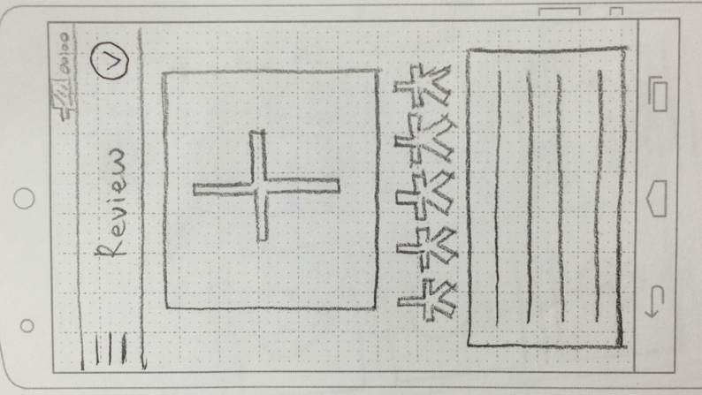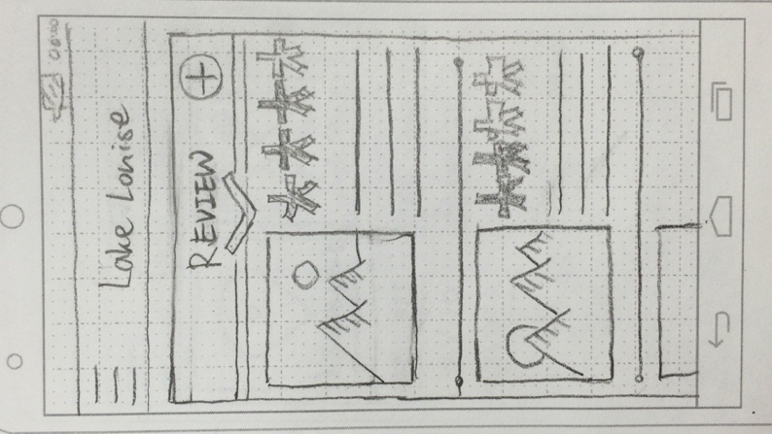

After skiing, he wants to make a review, so he taps the add button in the Review screen. He puts photo, rates by swiping, types in content, and taps the check button at the right top of screen.

# Task descriptions

## Task 7:

Terry is a member of the ski patrol at his local ski resort. He has just gotten back to the ski patrols main base. He checks his phone and sees a notification reporting that there is an injured skier on a nearby run! Terry then accesses the report by taping on the notification. He can see on the report that the skier was skiing with 1 other person who has begun to ski to the nearest chair lift to find help. Included in the report is a description of this second skier. Terry goes to the lift near his base. Eventually the second skier shows up and reports the injury, Terry marks the report as in progress and travels to meet the injured person. When Terry returns to the ski patrol base, he marks the report as completed and closes the app.

|  |  |  |
| --- | --- | --- |
| **Task step** | **Knowledgeable?**  **Motivated?**  **Believable** | **Comments/suggested fixes** |
| Turn on the phone | * We need to assume that he is knowledgeable enough to do this as our app cannot help him * He is motivated to do this since he wants to use our app * Yes | There is not much that we can have our app do to help him turn on his phone |
| Open our application | * We assume that if a user can turn on the phone that they can open an application * He is motivated to do this because he wants to check if there are any injured skiers * Yes. If the ski patrol is doing nothing, it is believable that they would check their phones | If we wanted to help Terry open the application, we could make it so that the application opens when the phone is turned on, however, we believe that overall, this feature would be detrimental to the success of our application. |
| Checks the notifications menu | * Terry works for the ski patrol, since he knows what to look for to help skiers, it is believable that he would know how to check the menu * Terry is motivated to check this because there will be a red dot over the button that will take a user to the notifications tab. This light will inform Terry that there is a new notification to check. | It might be helpful to allow each user to manually set what page the application opens to on default. This would allow Terry to never miss a notification. |
| Read the notifications | * The notifications will be in either English or Korean. So long as Terry speaks one of these, he is good. | It would be helpful to use the google language API to allow our app to be translated and allow more users |
| Mark the notification as in progress | * Terry may not know to do this depending on how long he has been using the application * Terry is motivated to do this as he wants to let his ski patrol fellows know that he has this problem | We need to have the button large enough so that people will know that they can mark a notification as in progress and a confirmation check so that a person dos ont accidently press it |
| Mark the notification as complete | * Terry may believe that once he marks the notification as in progress that there is nothing ore that he needs to do with the app. * Terry is now doing his ski patrol job; he will not be motivated to do this because he is working | After a user marks a job as in progress, they can get a reminder to mark the notification as complete, letting them know that they can and should do this. |
| Close the app | * No problems |  |

## Task 8:

Sam is a manager at a hotel near a ski resort. Sam’s hotel is having a weekend special on rooms for 4 or more people and needs to advertise this. Sam has advertised in other locations but wants to do more so he opens our app and finds the ski resort hear him. Sam then navigates over to the accommodations page, finds his hotel in the list, opens the page for his hotel, and posts an image describing the weekend deal with all important information. Terry then closes the app.

|  |  |  |
| --- | --- | --- |
| **Task step** | **Knowledgeable?**  **Motivated?**  **Believable** | **Comments/suggested fixes** |
| Turn on the phone | * No problem |  |
| Open our application |  |  |
|  |  |  |
|  |  |  |
|  |  |  |
|  |  |  |
|  |  |  |